**1) Longitudinal Automation Includes A Cooperative Adaptive Cruise Control System (CACC) Design**

**Draw A Block Diagram Of Your Cooperative Adaptive Cruise Control (CACC) System**.

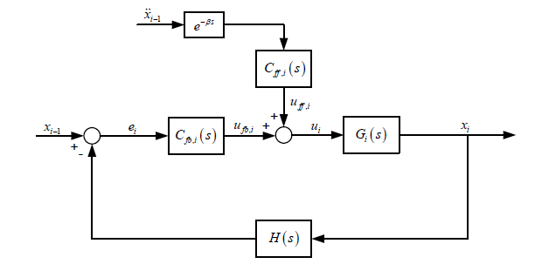

$$u_{i} is control input brake or throtte command$$

$$H\left(s\right) is feedback transfer function$$

$$x_{i} is position of i^{th} vehicle$$

$$x_{i-1} is position of {i-1}^{th} vehicle$$

$$c_{fb,i}\left(s\right) is feedback controller part$$

$$c_{ff,i}\left(s\right)is feedforward controller part$$

$$e^{-βs} time delay effect$$

$${\ddot{x}}_{i-1} is acceleration of {i-1}^{th} vehicle$$

**Build a basic longitudinal vehicle model. Then, use this individual model to obtain a vehicle convoy which includes at least eight vehicles.**

$$G_{i}\left(s\right)=\frac{X_{i}(s)}{U(s)}=\frac{1}{s^{2}(τ_{i}s+1)}$$

$$τ_{i} is denotes the uncertain time constant of the longitudinal vehicle dynamics$$

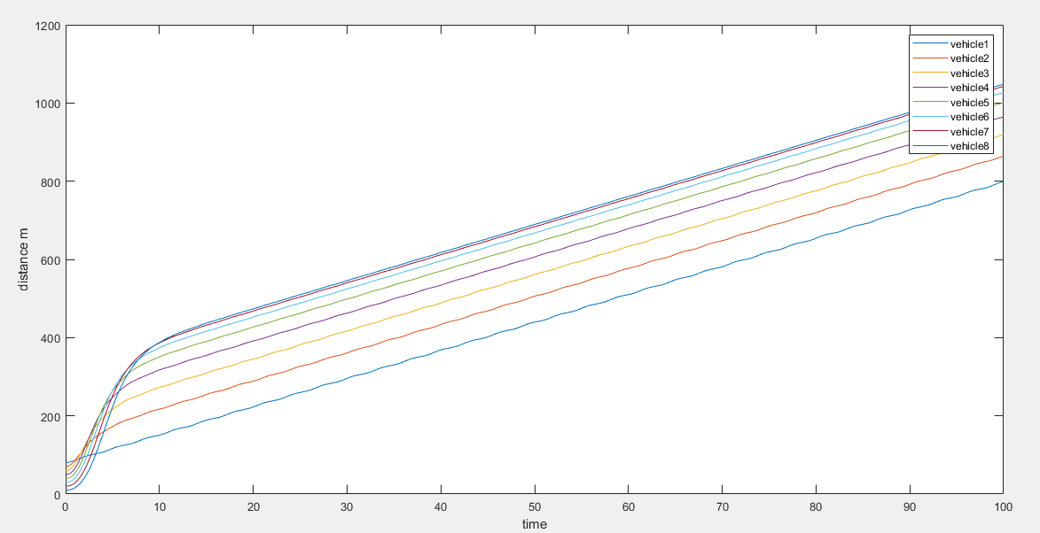

**Design a feedback and a feedforward control system for CACC by using a design method of your selection (linear, nonlinear, optimal, robust, adaptive control methods, etc.)**

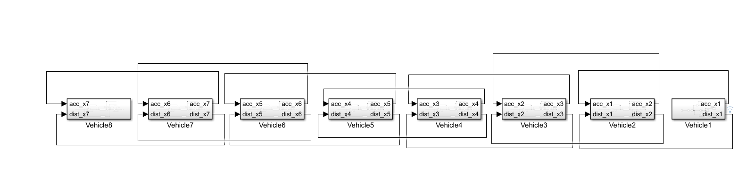

Inputs and outputs are acceleration and distances of vehicle

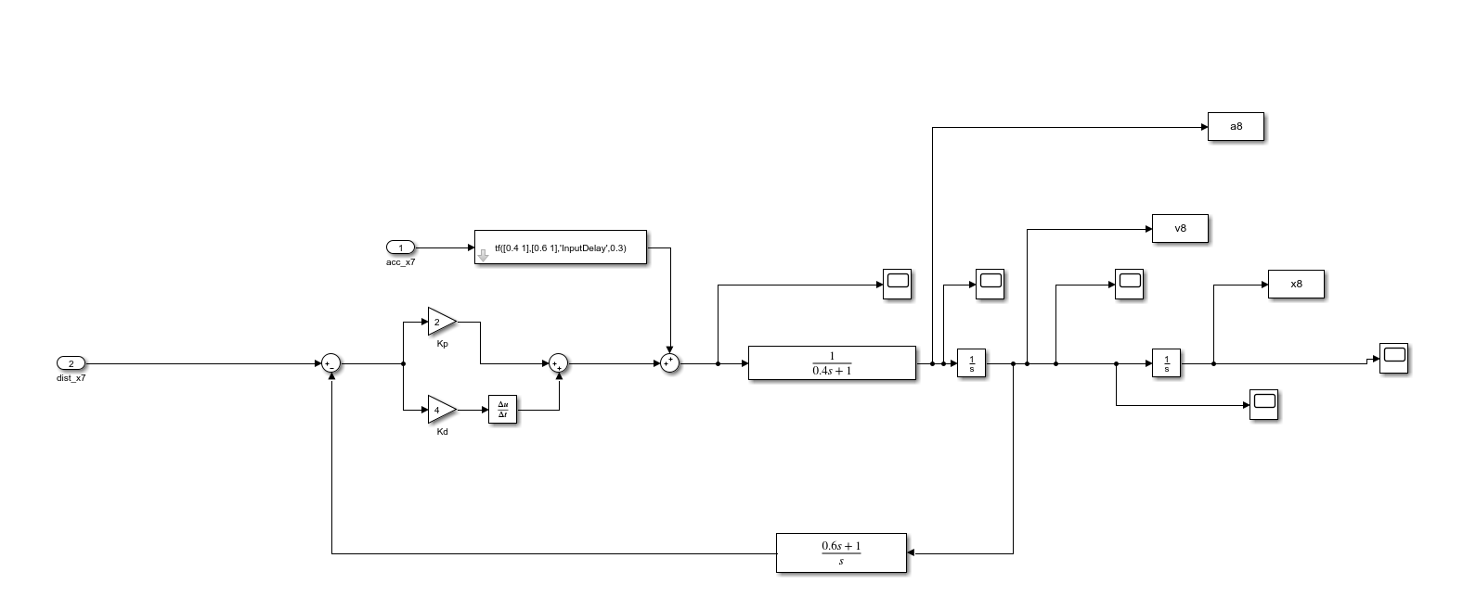

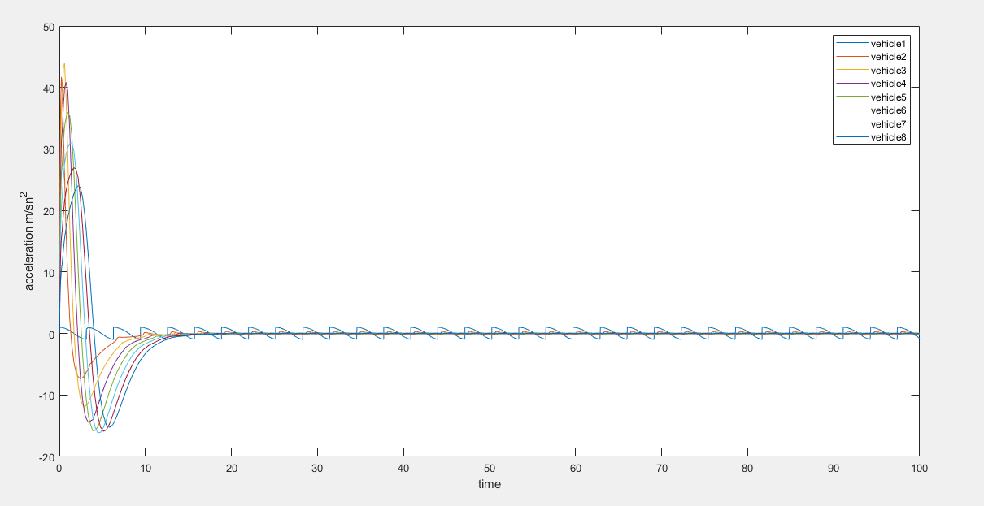

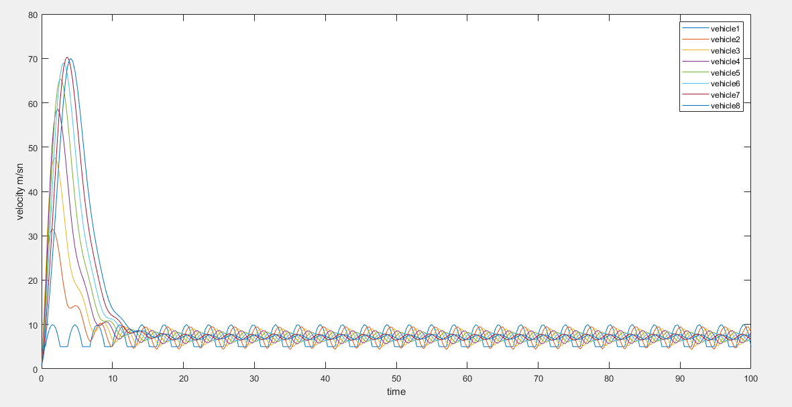

**2.)Explain your project topic briefly. What is the importance of your topic? Why did you select this topic? What are the proposed solutions for your project topic? What are your suggestions to improve the results?**

The paper proposes a Supervised Adaptive Dynamic Programming (SADP) algorithm for a full-range Adaptive Cruise Control (ACC) system, which can be formulated as a dynamic programming problem with stochastic demands.. A supervised ADP algorithm which introduces the concept of Inducing Region is here introduced to overcome such training drawbacks. The SADP algorithm performs very well in all simulation scenarios and always better than more traditional controllers. The conclusion is that the proposed SADP algorithm is an effective control methodology able to effectively address the full-range ACC problem.

Adaptive cruise control provides safety transportation also using machine learning in ACC provides optimization solution for emergency brake. In other solutions the emergency brake is not comfortable but it is comfortable .

In SAPD, SG(go and stop) should be improve. Because Hybrid PI controller is better results than SAPD